Tenants Portal

All Zerto Managed Service Providers (MSPs) will be required to register every end-customer ZORG within the MyZerto Tenants Portal. This allows the MSP to regulate the use of higher priced features like O2M and LTR, while also flagging VMs that count towards an end customer’s previously purchased license with Zerto, under the Bring-Your-Own-License model (BYOL). The Tenants Portal is also where the MSP can store added information about their end-customer’s ZORG, all of which is accessible via the Zerto Android/iPhone App or the MyZerto web portal.

Requirements for “Tenants”

In ZVM:

1. ZVM must have “Enable Zerto SaaS applications” enabled under the “About” section of Zerto site settings

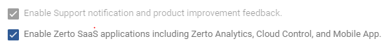

1. ZVM must have port 443 open to <https://zerto-mobile-data.zerto.com>
2. ZVM version 5.5u4 or higher
3. User must be registered user in MyZerto with their work email domain address

How to Access “Tenants”

1. Log into MyZerto (www.zerto.com/myzerto)
2. Select “Cloud Control” from the navigation bar – will open in a new tab



1. Select “Tenants”



How to “Add” a new “ZORG” in “Tenants”

1. Click “Add” in the top right

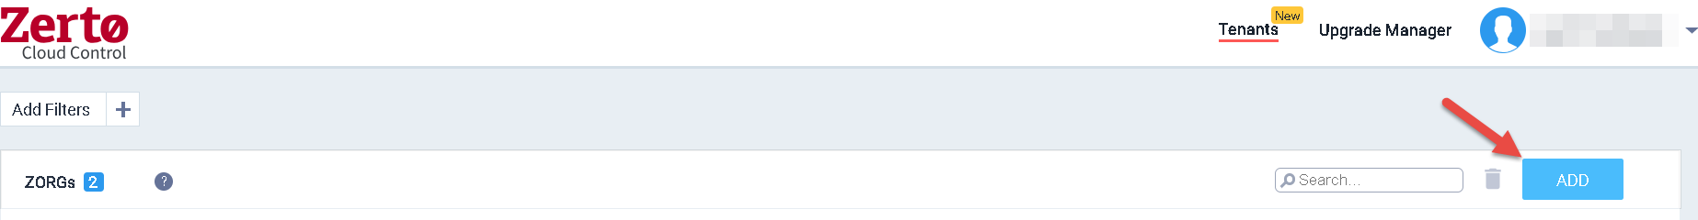

1. Select the appropriate ZORG by clicking on the “ZORG Name” field – note that typing in this field will filter the list.

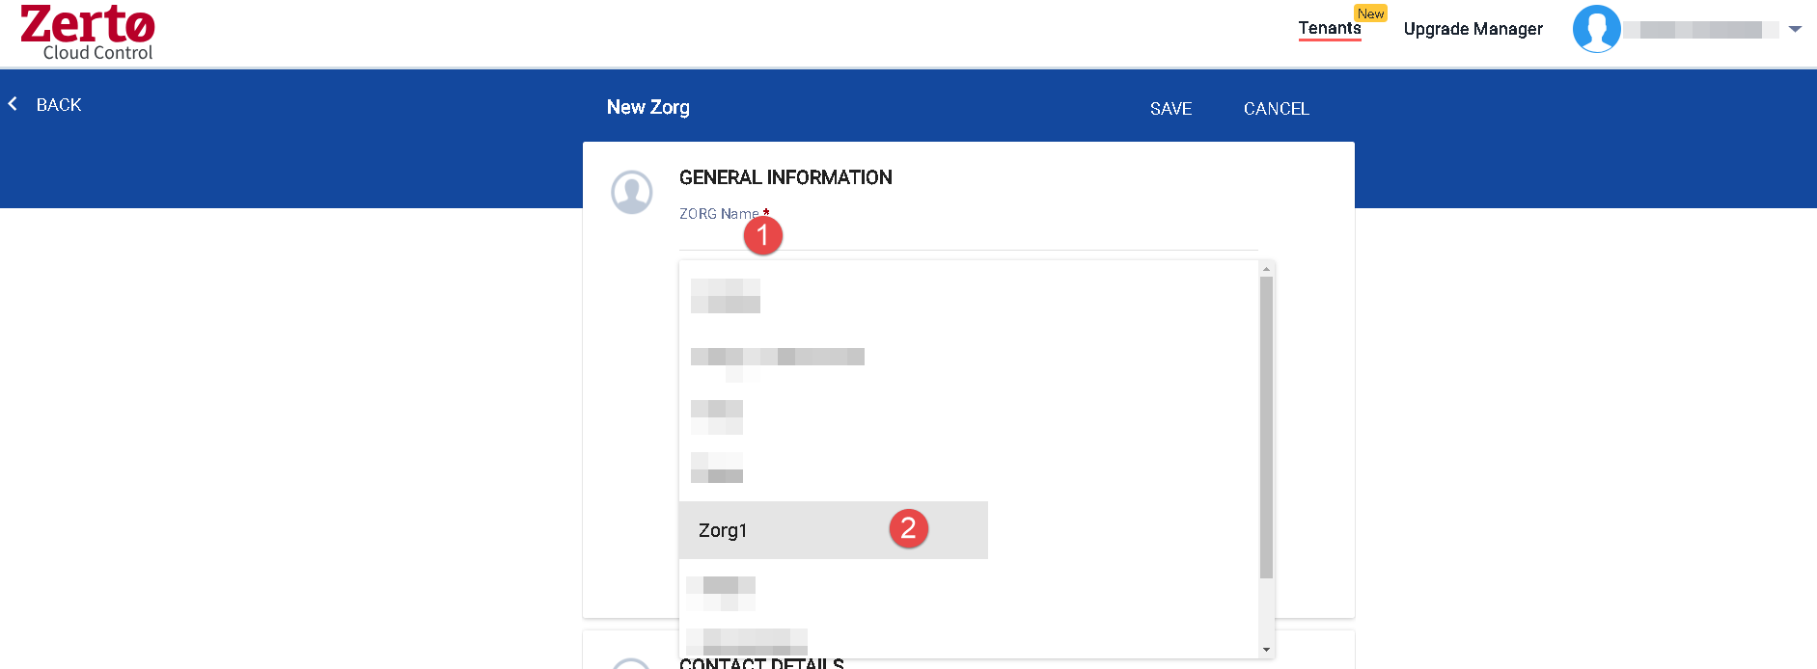

1. Fill in the other required fields.

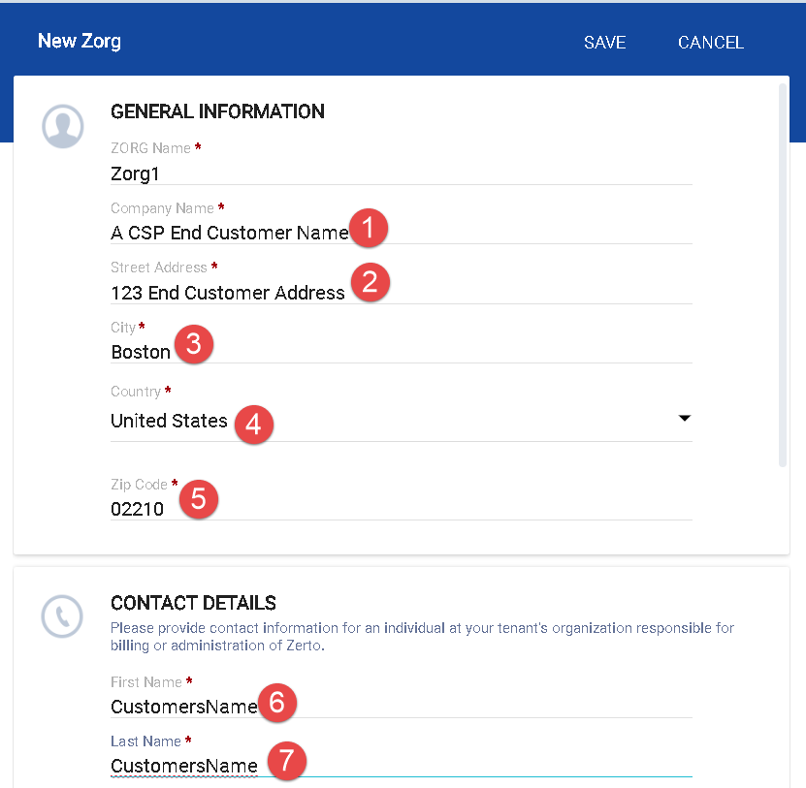

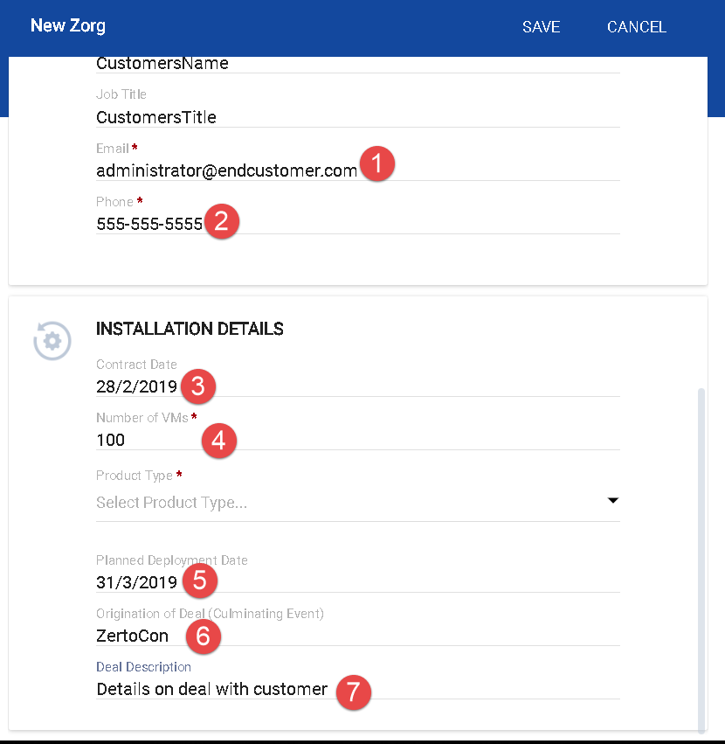

1. Select a product type:
   1. Software Subscription: Zerto Virtual Replication (ZVR) provides protection for virtual machines in Service Provider site.
      1. **Usage for this ZORG is billed at the provider’s regular rate. (list $30)**
   2. Multi Cloud: ZVR Multi-Cloud (MC) enables one-to-many, simultaneous protection and recovery of VMs within on-premise and multiple Service Provider sites, for up to 3 sites
      1. **Usage for this ZORG is billed at the provider’s premium rate. (list $39)**
   3. Enterprise Cloud Customer: Enterprise Cloud Customers (ECC) with an existing perpetual ECE license and a valid maintenance and support agreement for such a license with Zerto, who will now be using a Service Provider for replication for one of their sites
      1. **Usage up to the enterprise customer’s ECE license amount for this ZORG is billed at $0.**
   4. Migration:
      1. **Migration is to be used for customer workloads that will be migrating to, from, or within your cloud sites. Once the customer's migration is complete, the ZORG's product type should be updated to better reflect their ongoing services.**

|  |
| --- |
|  |

1. Click “Save”

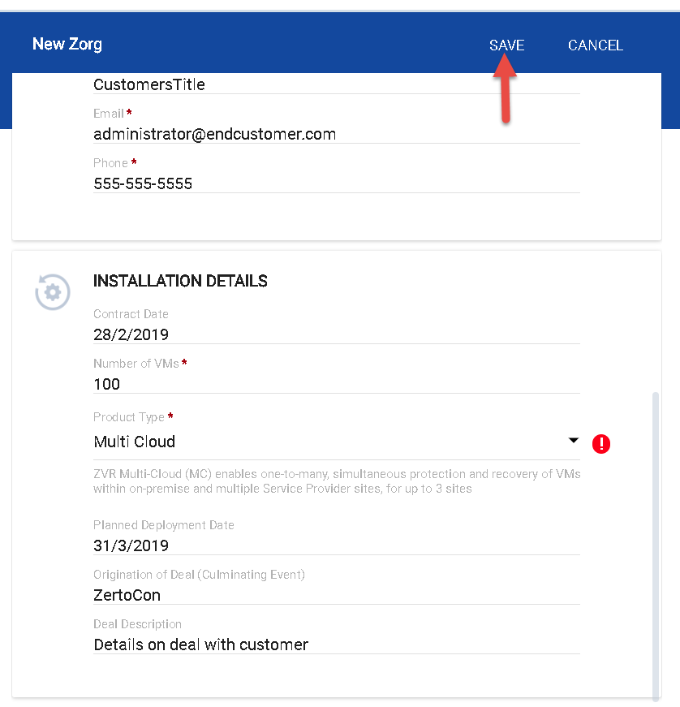

How to edit an existing “ZORG” in “Tenants”

1. Click the link for the “ZORG” you wish to edit

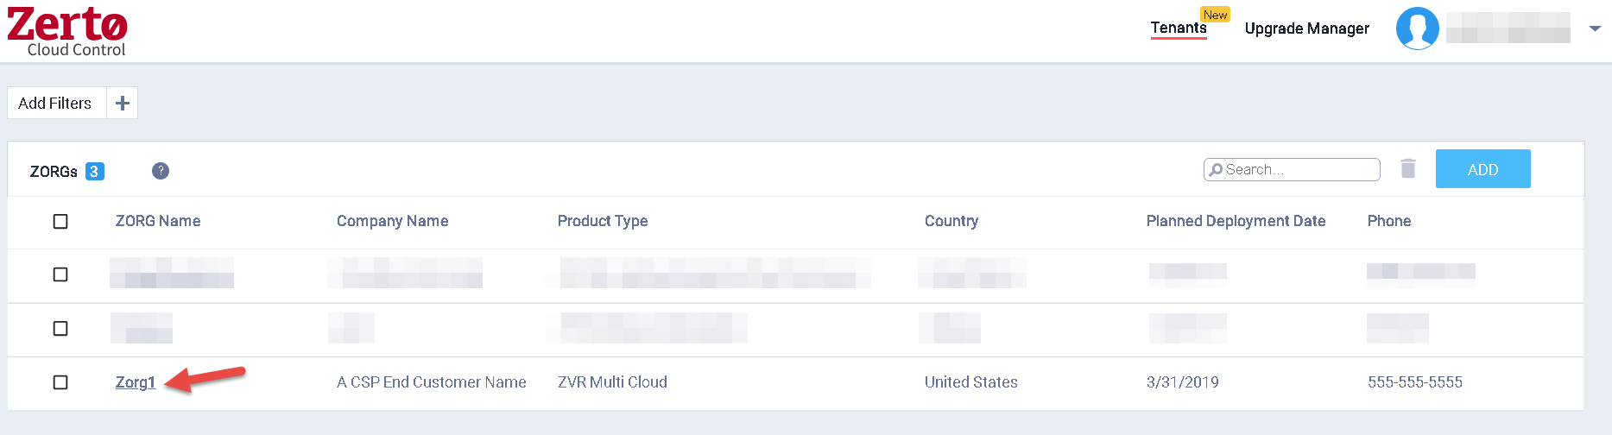

1. Click the “Edit” pencil icon in the top right

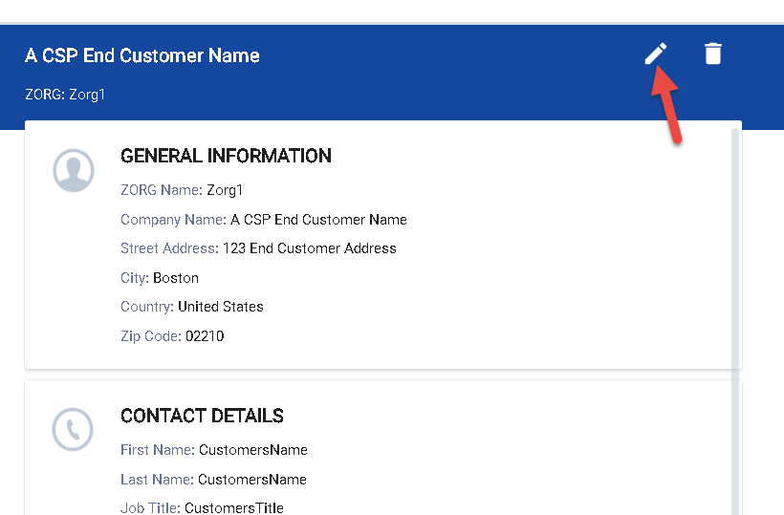

1. Make the desired changes and click “Save”

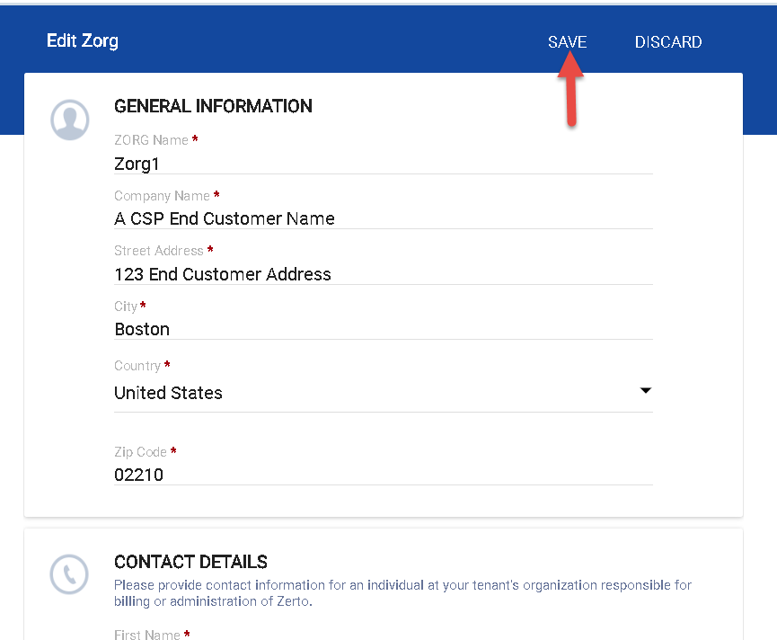

How to Delete a “ZORG” in “Tenants”

Method 1

1. Select the check box for the desired ZORG and click the “Delete” trash can icon

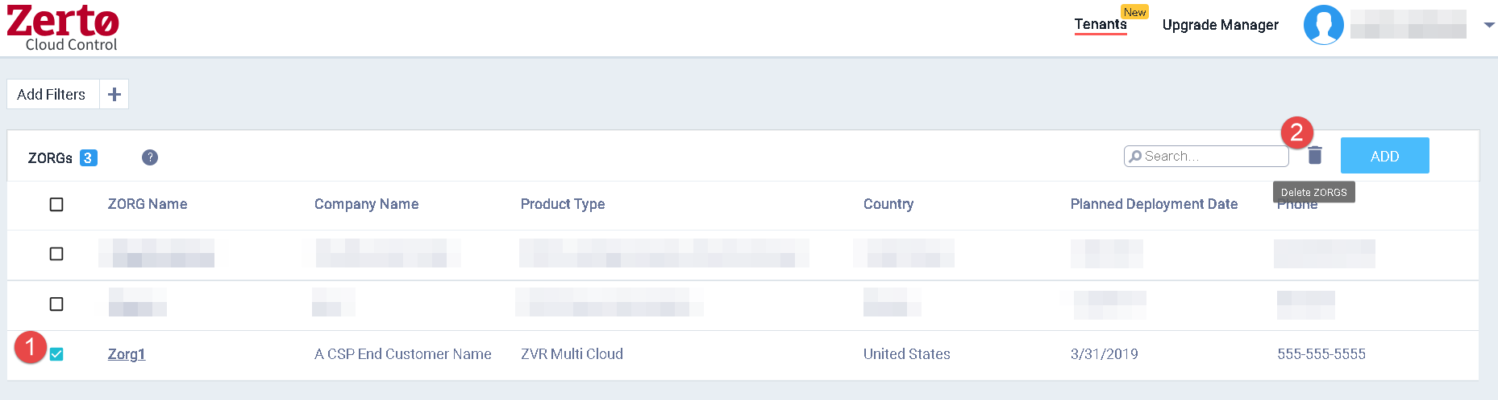

Method 2

1. Click the link for the “ZORG” you wish to delete
2. Click the “Delete” trash can icon in the top right

